**Project Design Phase-II**

**Data Flow Diagram & User Stories**

|  |  |
| --- | --- |
| Date | 7 NOVEMBER 2022 |
| Team ID | PNT2022TMID13490 |
| Project Name | Gas Leakage Monitoring & Alerting System |
| Maximum Marks | 4 Marks |

**Data Flow Diagram:**

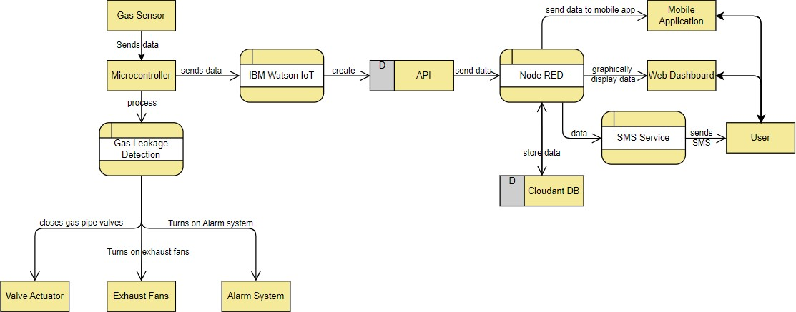

**Flow Chart**

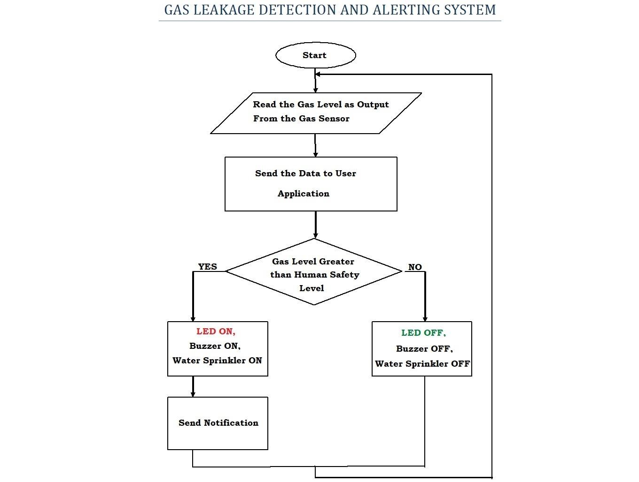

**User Stories**

|  |  |  |  |  |  |  |
| --- | --- | --- | --- | --- | --- | --- |
| **User Type** | **Functional**  **Requirement (Epic)** | **User Story**  **Number** | **User Story / Task** | **Acceptance criteria** | **Priority** | **Release** |
| Customer  (Industry owner) | Registration | USN-1 | As a user, I can register for the application by entering my email, password, and confirming my password. | Register to the application by email and password with password confirmation. | High | Sprint-1 |
| Customer  (Industry Owner) | Confirmation | USN-2 | I will receive confirmation email once I have registered for the application | Receive confirmation email & click confirm | High | Sprint-1 |
| Customer  (Industry Owner) | Authorize | USN-3 | As a user, I will enable the supervisor to monitor the gas leakage system status. | Provide access to supervisor. | High | Sprint-1 |
| Customer (Supervisor) | Login | USN-4 | As a user, I can log into the application by entering email & password. | Get access to dashboard. | High | Sprint-1 |
| Customer  (Supervisor) | Monitor | USN-5 | As a user, I can monitor the status of the gas leakage system. | Status of gas leakage system. | High | Sprint-1 |
| Customer  (Line Workers) | Notification | USN-6 | As a user, I can get (alarm system) alert about gas leakage. | Get alert about gas leak. | Medium | Sprint-2 |
| Customer  (Supervisor) | Notification | USN-7 | As a user, I can get SMS notification & alarming alert about gas leakage. | Get alert about gas leakage. | Medium | Sprint-2 |
| Customer  (Industry Owner) | Sign-Up | USN-9 | As a user, I can sign-up using Facebook login. | I can sign-up with the application using Facebook. | Low | Sprint-3 |
| Customer  (Supervisor) | Sign-Up | USN-10 | As a user, I can sign-up using Google login. | I can sign-up with the application  Google using. | Low | Sprint-3 |
| Administrator | Service Request | USN-11 | As a user, I can request for service in case of any issue with gas leakage monitoring system | Get service from provider | Low | Sprint-3 |
| Administrator | Increase dservice | USN-12 | As a user, I can request for scaling up the gas leakage monitoring system. | Get service from the provider. | Low | Sprint-4 |
| Customer (Industry Supervisor) | Leakage detection | USN-13 | Look for gas leakage in any other container | Access the monitor Display | High | Sprint-1 |